Unit 15.C. Website Development

Youssef shetta

2019

Contents

C. Develop a website to meet client requirements 3

C1 Client-side scripting languages 3

Use of scripting languages 3

Alerts 3

Confirming choices 4

Browser detection 4

Creating rollovers 5

Handling forms 6

Validating input 6

Constructs 7

Loops 7

Decision making 7

Functions 7

Parameter passing 8

Handling events 8

Methods 8

P4 & P6C2 website development 9

CSS & linking the CSS to the HTML 9

Header 10

Subscriptions and Merchandise (and editing images) 11

Adding buttons/lists 12

Adding navigation bar 12

Social media links 13

Including downloadable resources (Going Green) 13

Creating the charity profile 14

Creating the donation section 14

Implementing the blog 15

P5 Testing the website for functionality, compatibility and usability. 16

Testing 16

M3 optimise a website to meet client requirements 18

D3 Demonstrate individual responsibility, creativity and effective self-management in the design, development and review of the website. 19

# C. Develop a website to meet client requirements

When developing a website to meet client requirements there must be a design (which is in section B) and the assists must be collected and approved by the client, then the development process can be initiated.

## C1 Client-side scripting languages

HTML is the basis of all webpages as it’s a limited other languages need to brought in to create more advanced features on webpages. A client side scripting language is used to write code that is embedded into the HTML. When the web page is downloaded onto the user’s browser the script is run on the user’s computer. Examples of client-side scripting languages are VBScript and JavaScript, these are languages that offer a way to process things on the client’s pc and not on the website’s server, this gives the server less strain and in turn makes it faster to load, the only disadvantage is that if a visitor has a pc that is really old it might have trouble keeping up with it. But modern pcs would not have trouble dealing with client side scripting.

## Use of scripting languages

Below are some uses of JavaScript, I will be using one or two of them to help better and warn the user’s experience.

### Alerts

Pop-ups to alert the user to something.

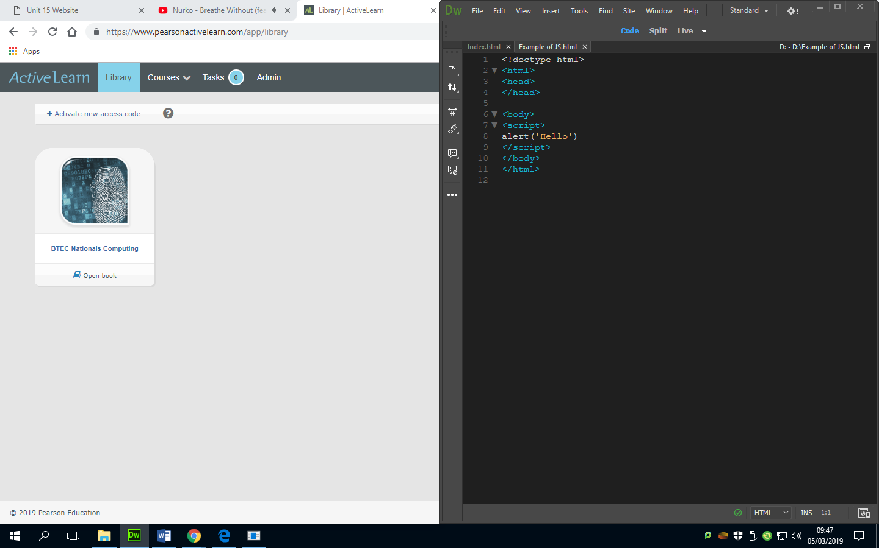

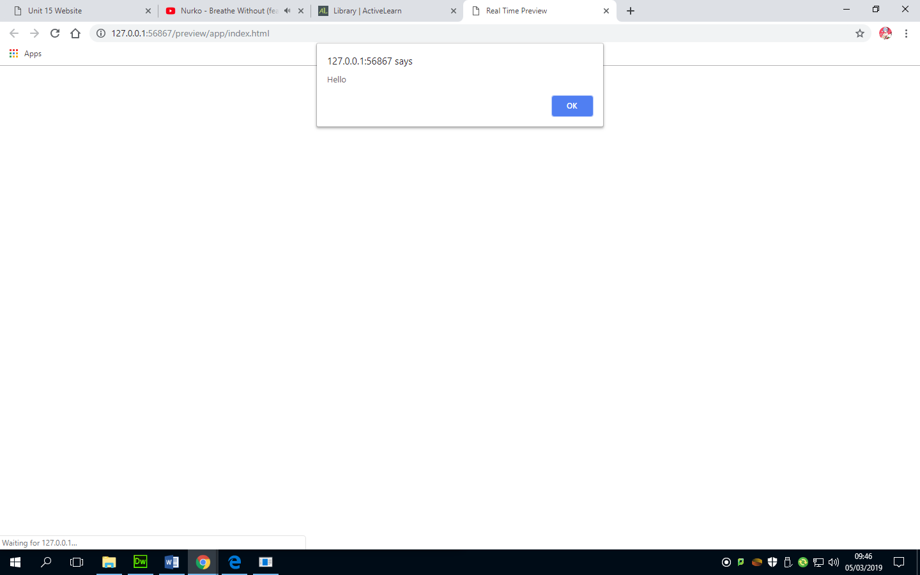

### Confirming choices

This is a form of validation. This gives a user the opportunity to check if they are sure that they clicked the correct option. I will be using this to let them know that they are leaving the website to enter the blog.

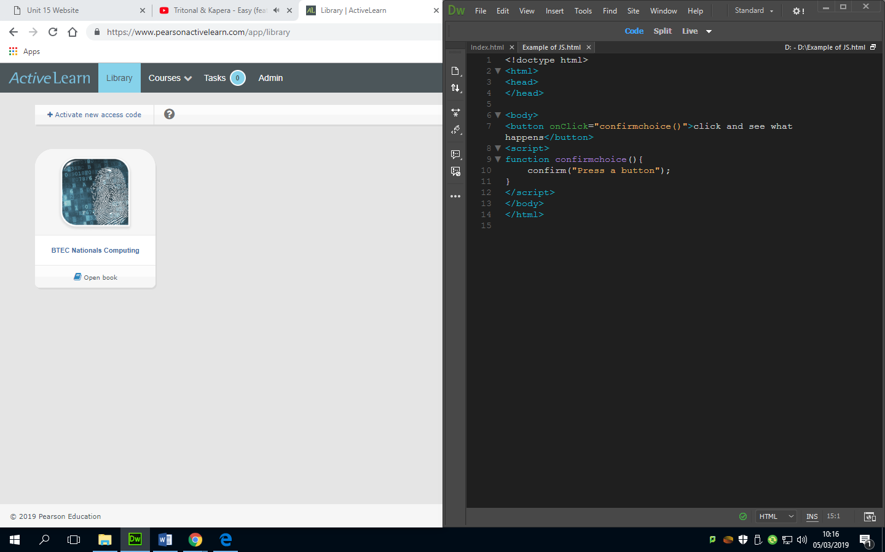

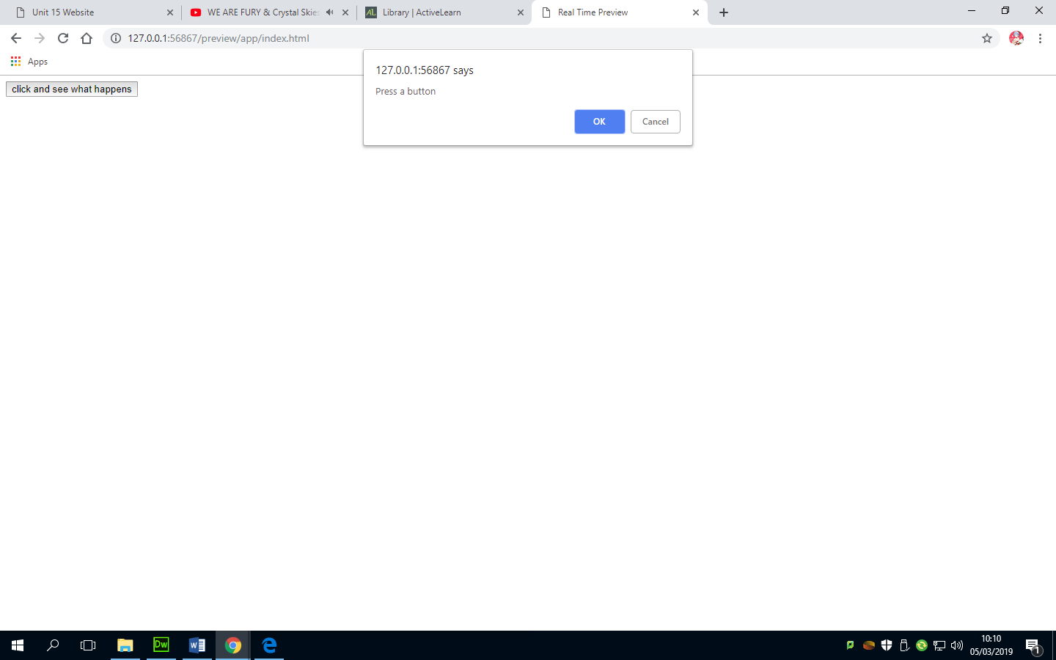

### Browser detection

This is used to determine what browser the visitor is using. Below you can see what the code looks like and what the output looks like, but there is not an output to the visitor, which is good as it’s useless information for the user to have anyway.

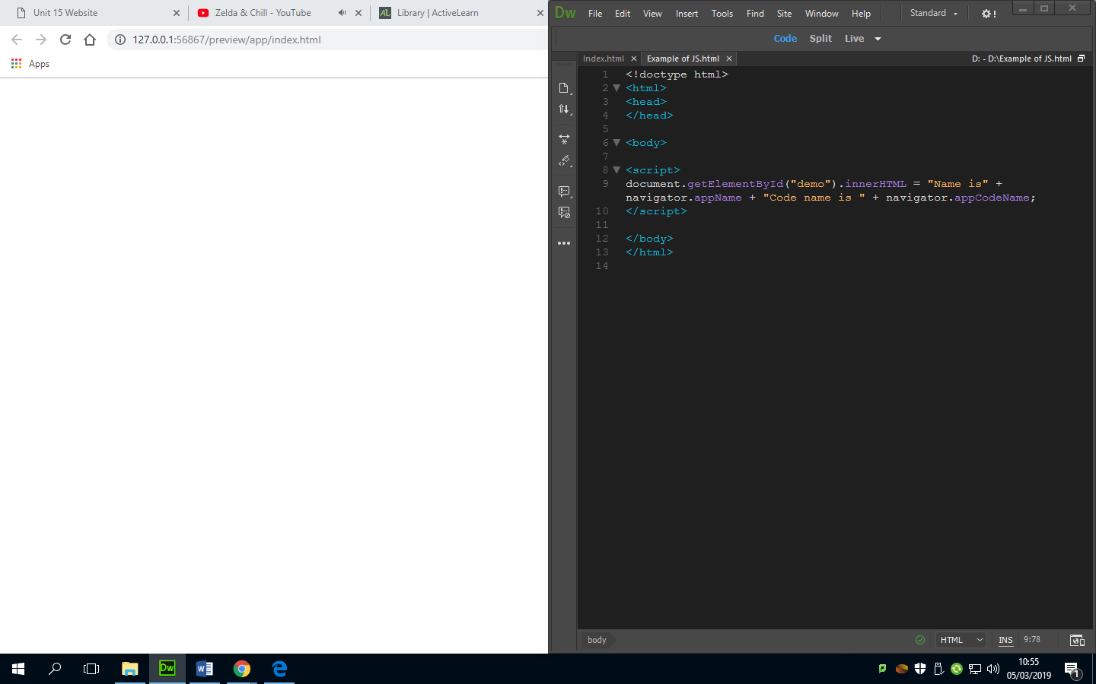

### Creating rollovers

Rollovers add more visual interactivity. A web page can use rollover images or in this case buttons.

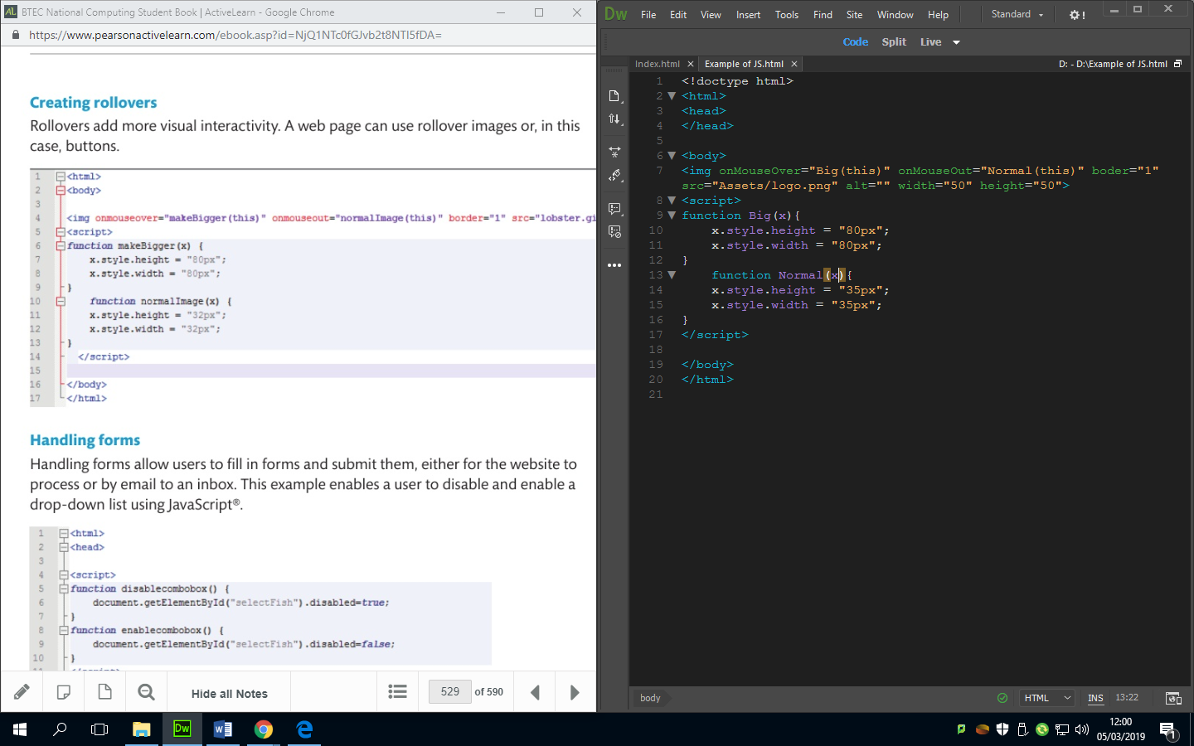

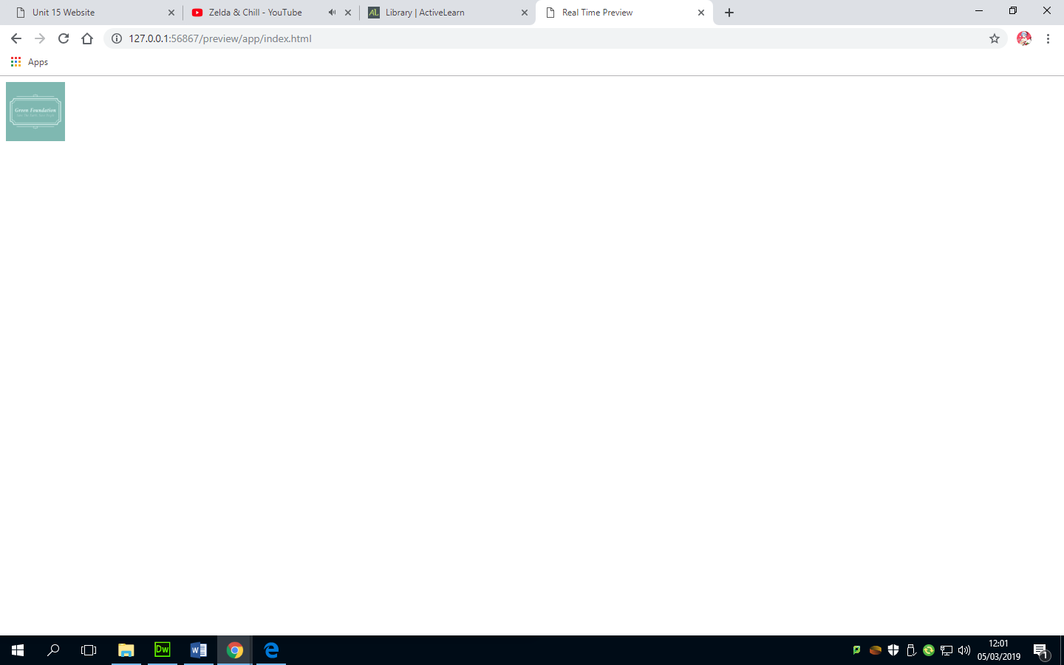

### Handling forms

Handling forms allow users to fill in forms and submit them, either for the website to process or by email to an inbox. This example enables a user to disable and enable a drop down list using JavaScript.

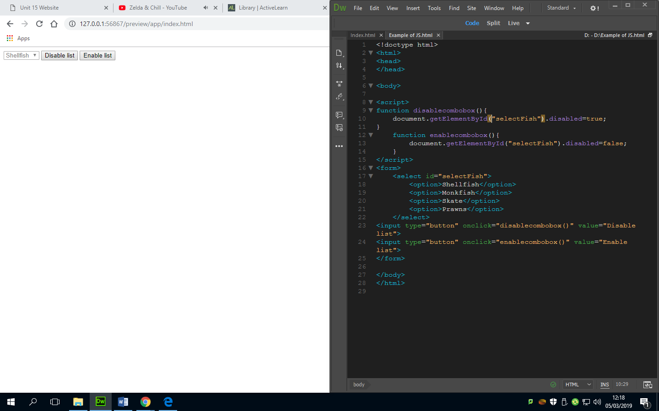

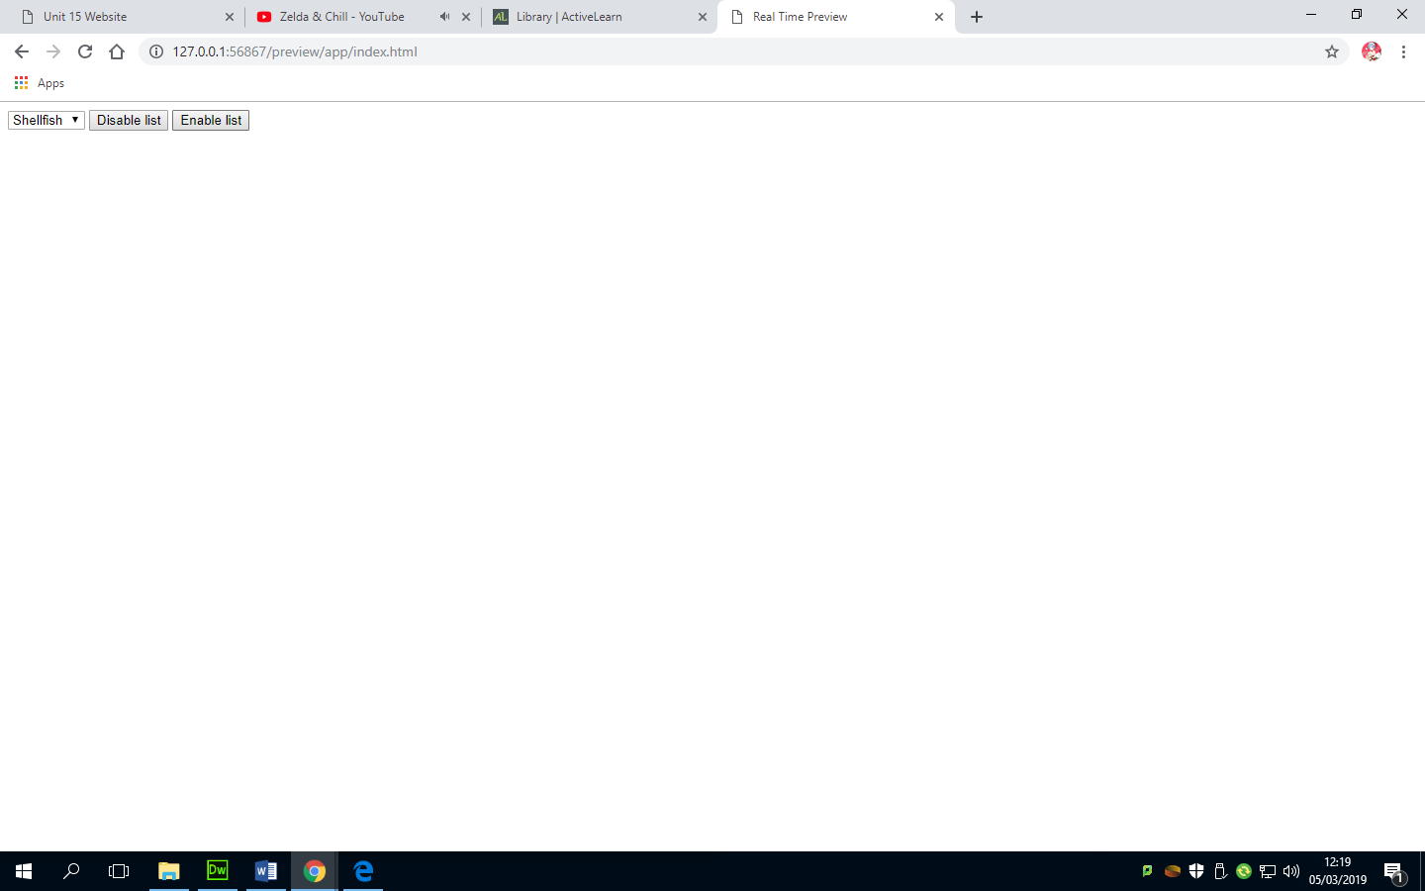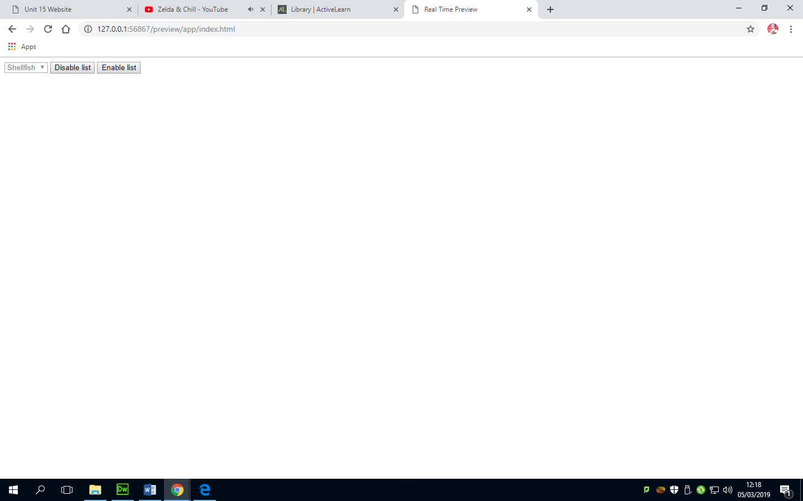

### Validating input

Validating input is a technique used to see if a user has entered text within a textbox.

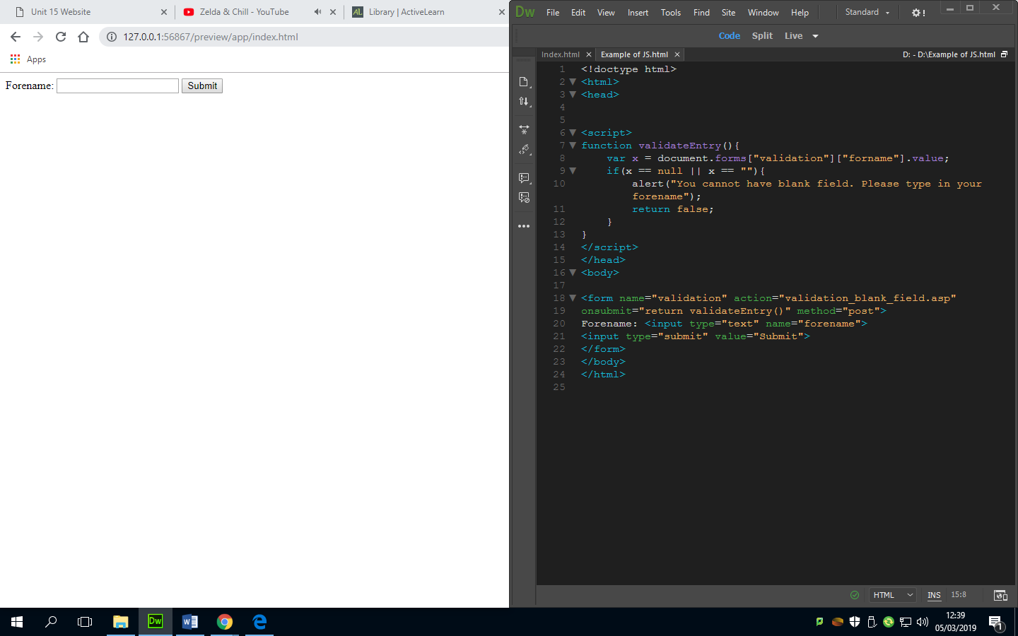

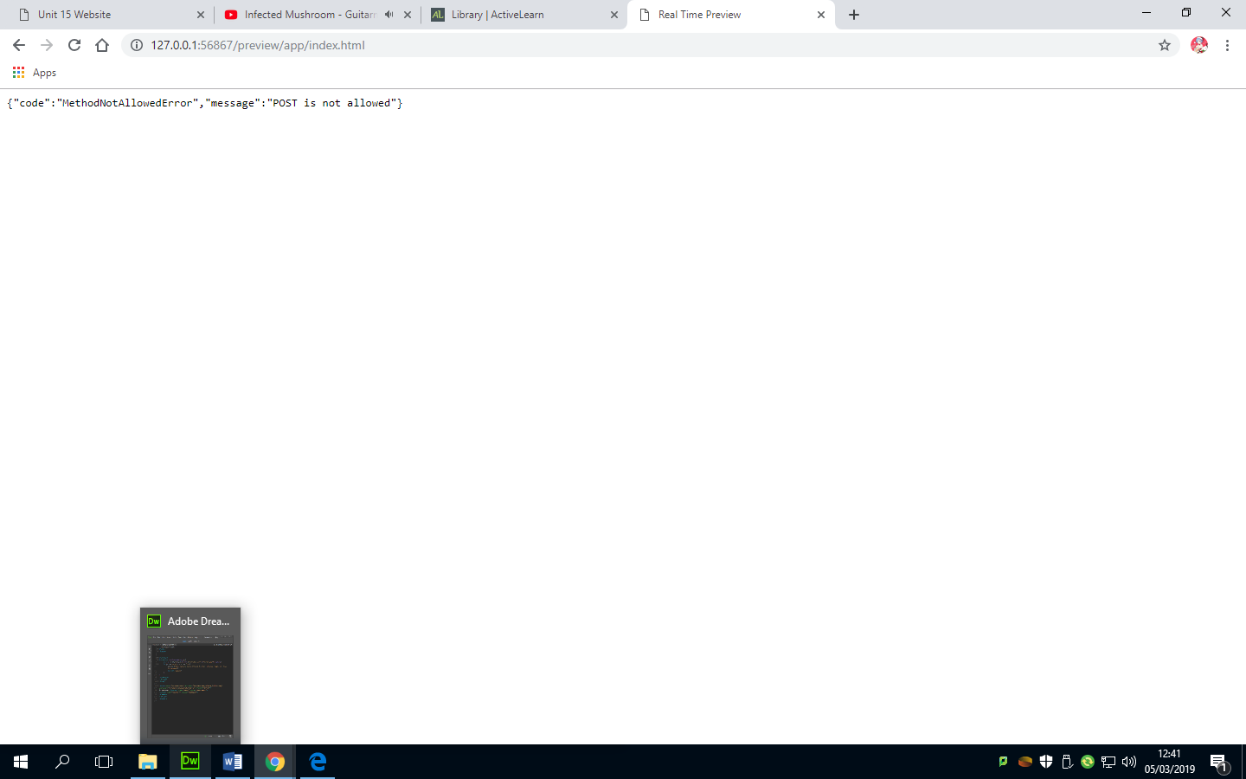

## Constructs

Constructs are syntactically permissible parts of a program and must be used in accordance with the rules of the programming language you are using. For example scripting languages need to use the correct construction in order to work. This includes the syntax. It is important for any programming language that the syntax is correct. Below is a list of some constructs:

### Loops

Loops are useful if the same part of the program needs to be run repeatedly.

### Decision making

This is the process of forcing the user to make a choice on the webpage for example when they want to leave the website to access the Green foundation’s blog, since it’s an external website we need to make them understand that before they leave because it might look like its apart of our website sense it’s in our navigation bar.



### Functions

Functions are used to create less redundant code sense I can just make one block of code that is executed under one name. This makes the code more efficient and in our case makes the website load faster.

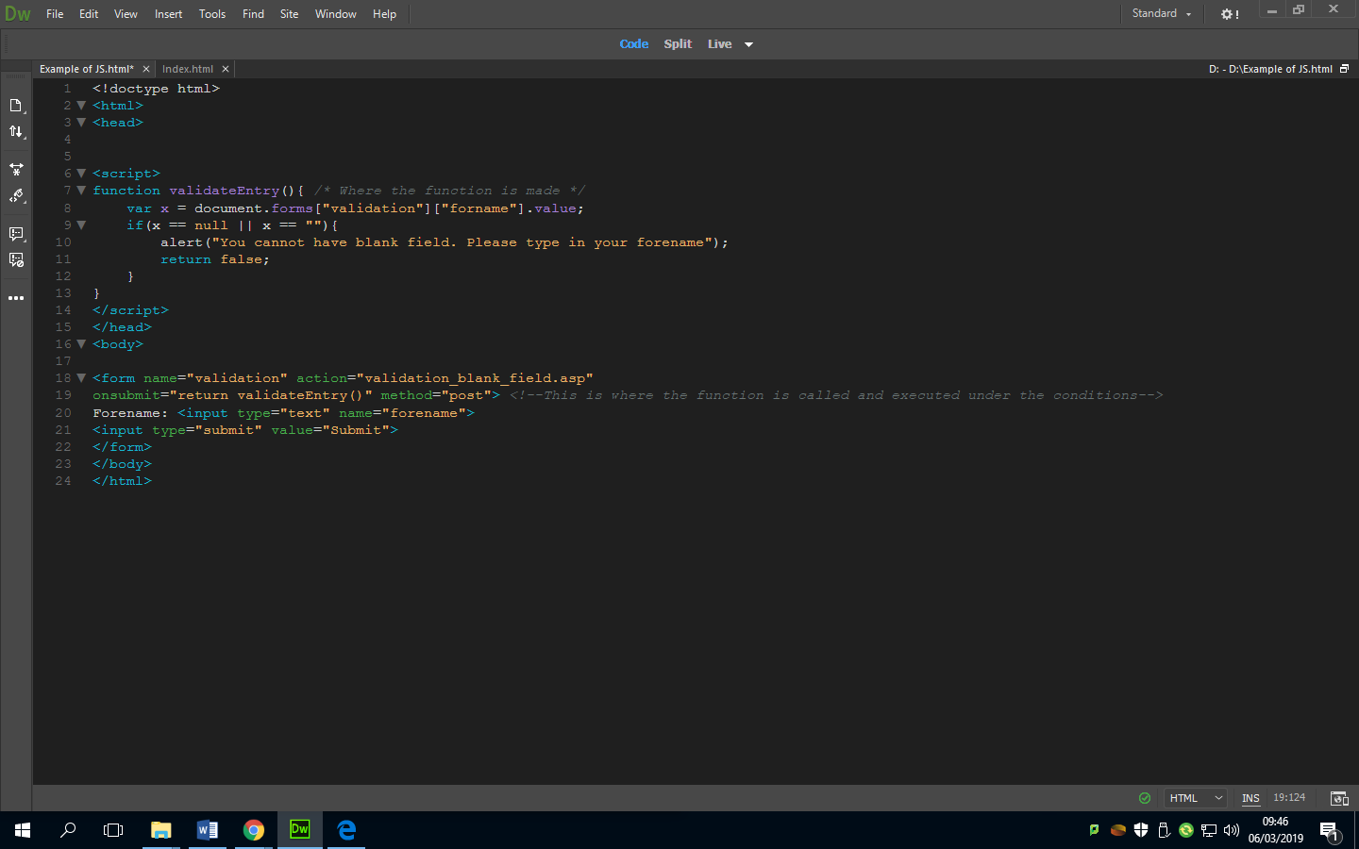

### Parameter passing

This occurs when a value (x is an example below) is being passed to function and then the function uses it while it is running.



### Handling events

These are things that happen based upon a user’s interaction with the website or something that the browser does. For example clicking on a button on the navigation bar and it loads another page.

### Methods

A method is an action that can be performed by an object. For example a visitor clicking a button and it performs a block of code that stops them from accessing an area of the website.



## P4 & P6C2 website development

In this section of the report I will be talking about the process I went through when developing the website, this includes CSS, HTML tags, box modelling, accessing CSS from HTML and doc types.

### CSS & linking the CSS to the HTML

CSS allows me to create a standard layout and style of the webpage which I can use more easily on each web page that I create so that I don’t have to keep recreating the same variables. This makes the website more consistent in its design. It is also much easier to maintain the website because all the variables are in one place with titles that link them to what they edit/effect. For example the background colour and the sizing of images like the logo. To link the CSS to the HTML I used the link tag from HTML library.

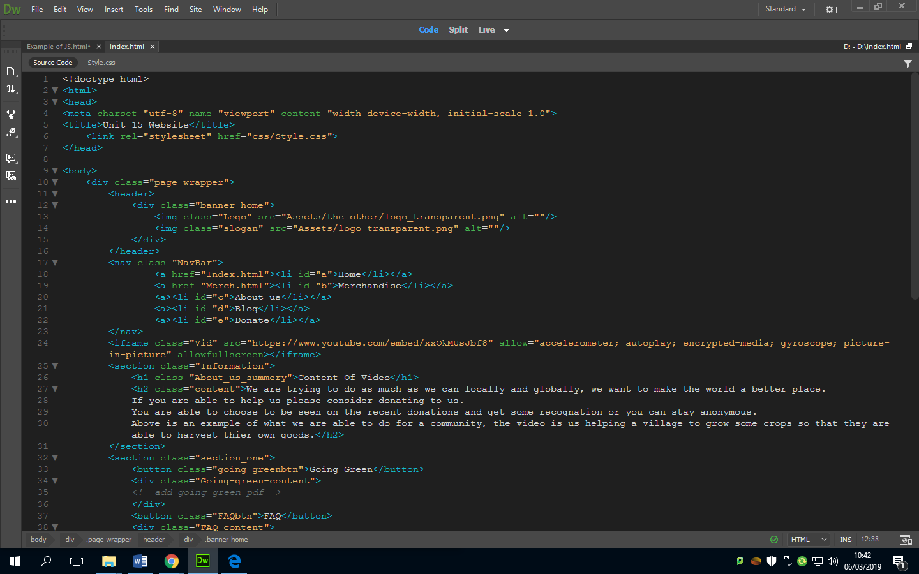

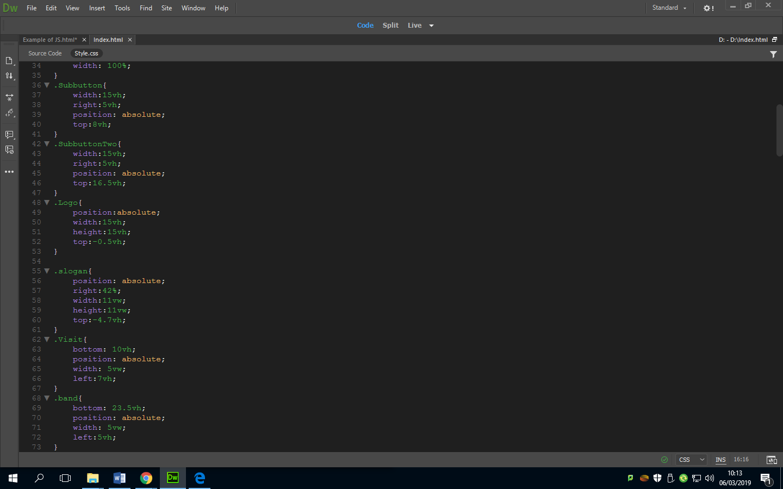

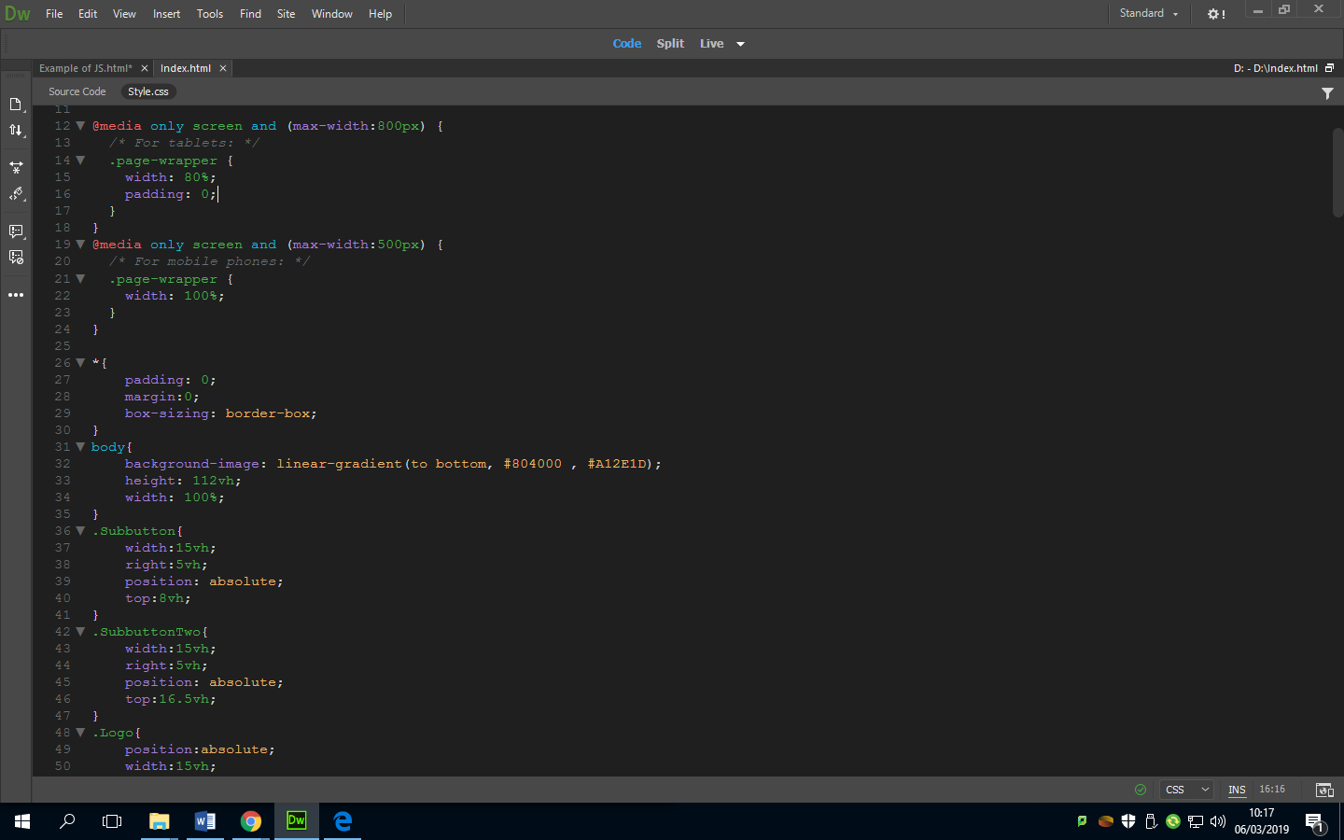This makes the background of the website a gradient like in the design.

### Header

To create my header I had to create shapes and classes for those shapes so that I can edit them in the CSS, this made it multi-layered but it looked the same way as my design so I didn’t change much as I tried to follow my design/plan but what I did change was the white space around the frame of the website, on my design I didn’t have white spacing but I changed it when creating the website because everything was too stretched.

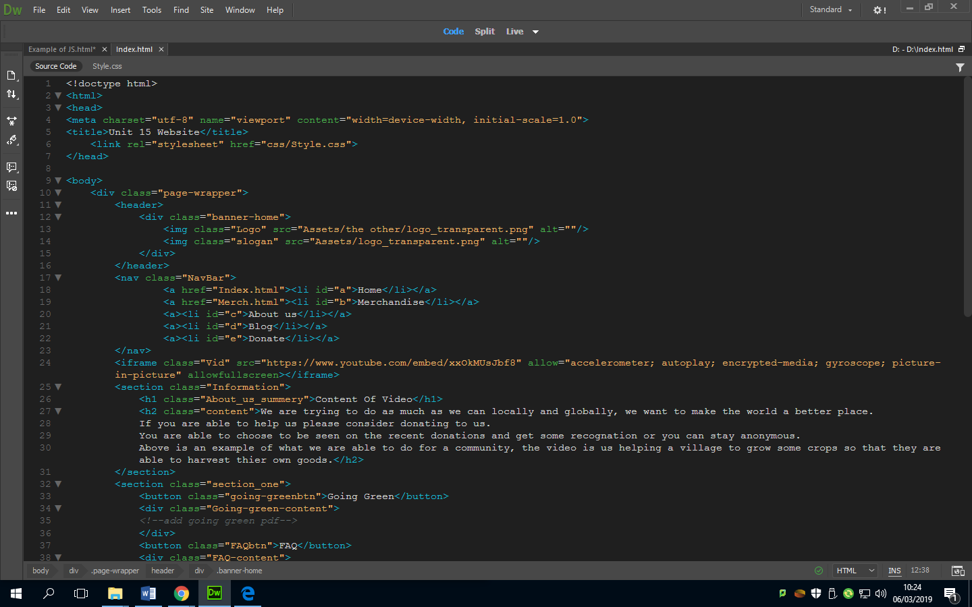Above is where I created a class in the HTML so that I can call on it in the CSS. The class acted like a border around the images I inputted so that I was able to make it look like a website header.

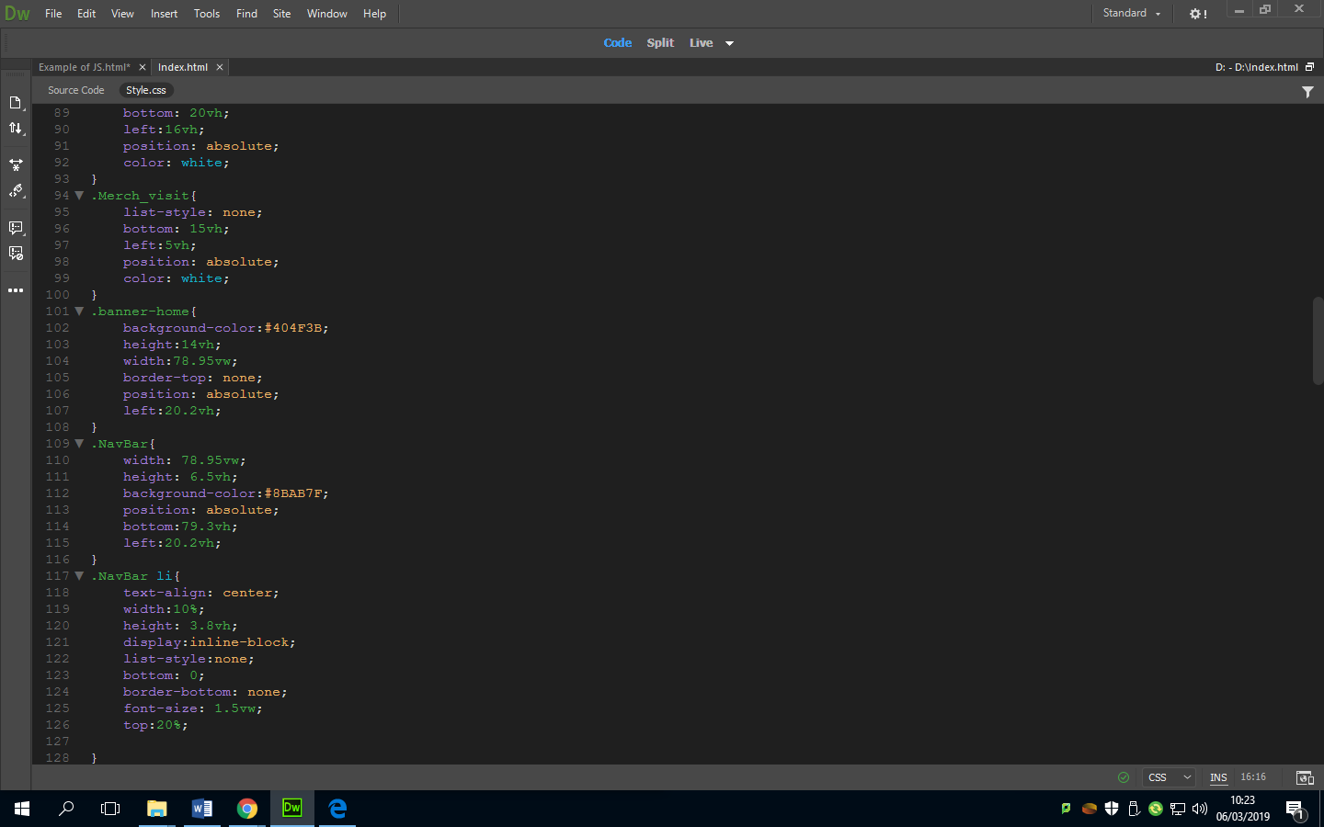To the left is where all the CSS for the banner home is defined and edited to make it suit the design.  
Below is what it looks like.

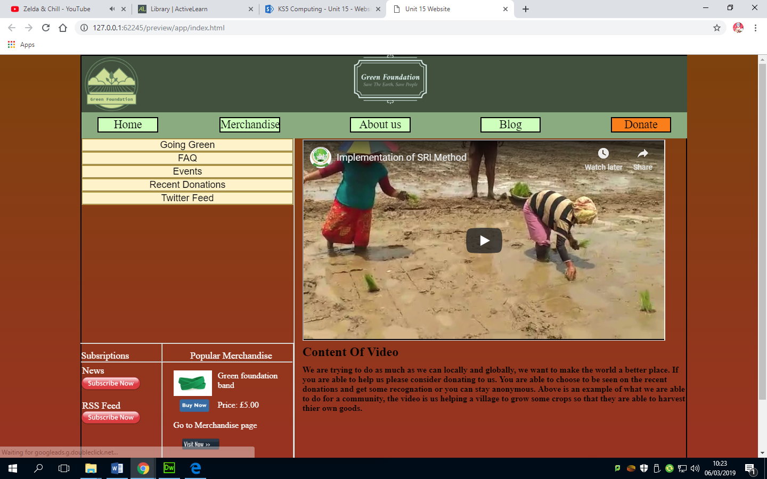

### Subscriptions and Merchandise (and editing images)

The website design included a lot of images so it’s natural that I would need to know how to make the images resize and to be able to position them in the way I want. Below is the subscriptions for the new and RSS feed. And next to that is the popular merchandise, these were added because the client’s requirements wanted people to be able to subscribe to the newsletter and the RSS feed. And they wanted to generate sales from the merchandise so I thought of making a link to the merchandise page and products at the home page.

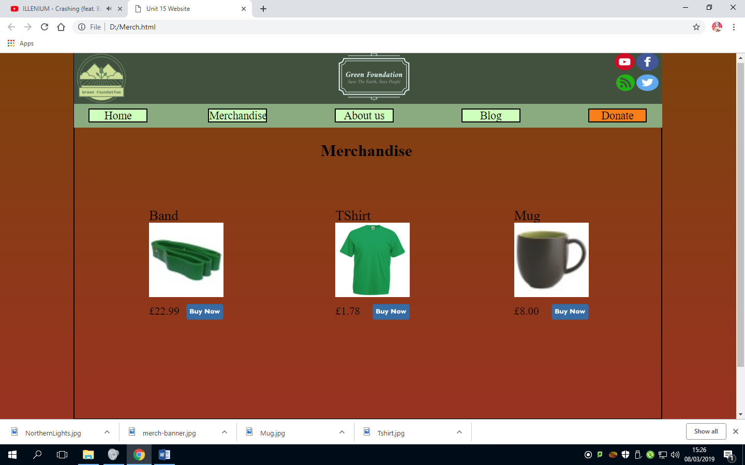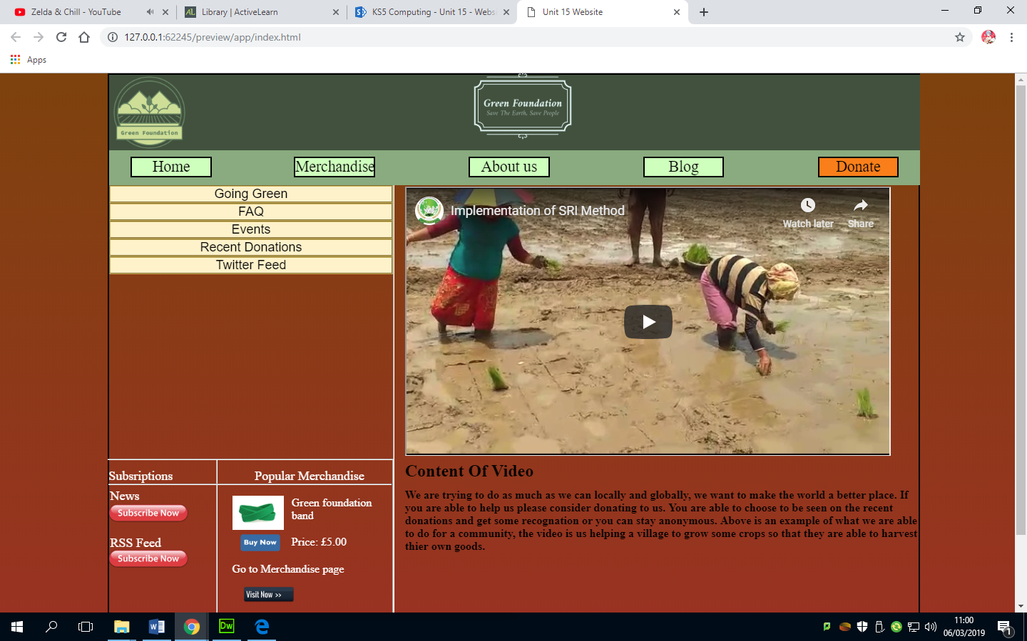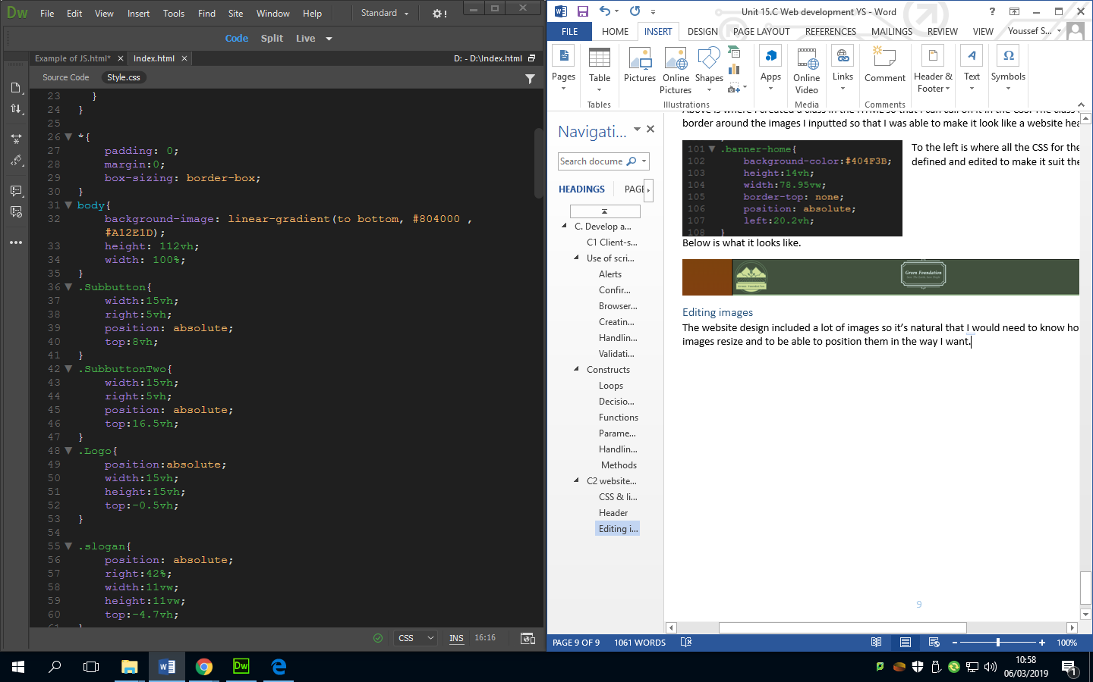

### Adding buttons/lists

For my website I wanted dropdowns to present information to the user without taking too much space so that I can have enough space on the webpage to present the information that is important. This is done by using buttons and lists. These can be created by using the HTML tags <LI> and <button>.

HTML

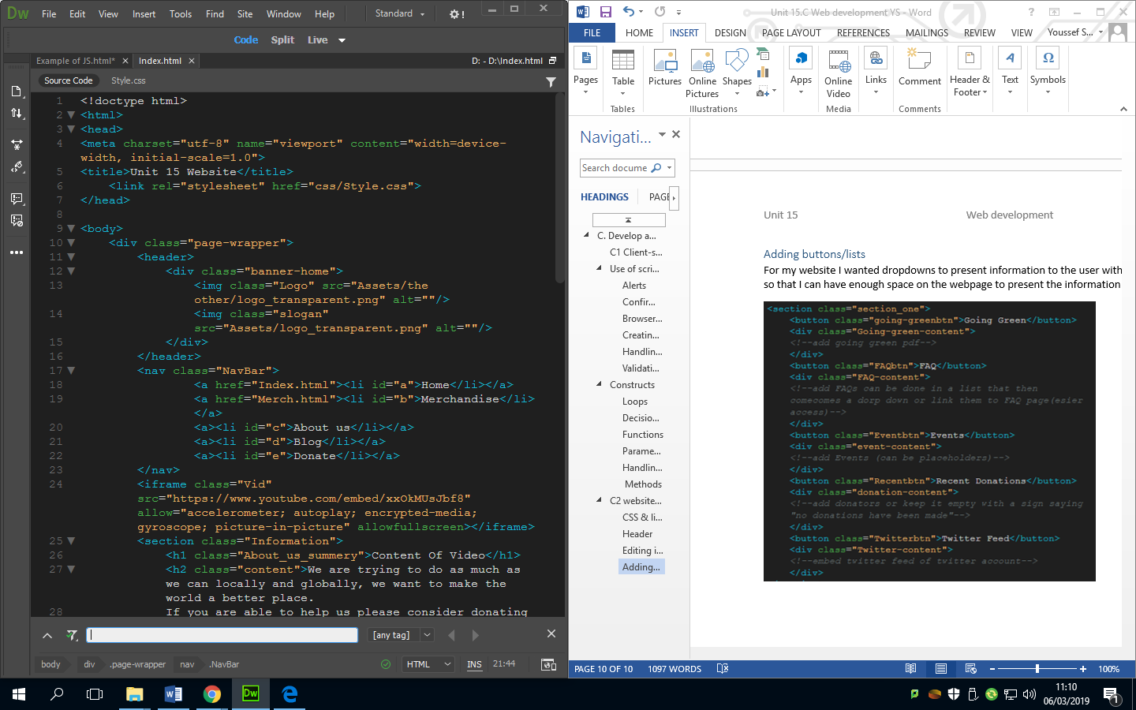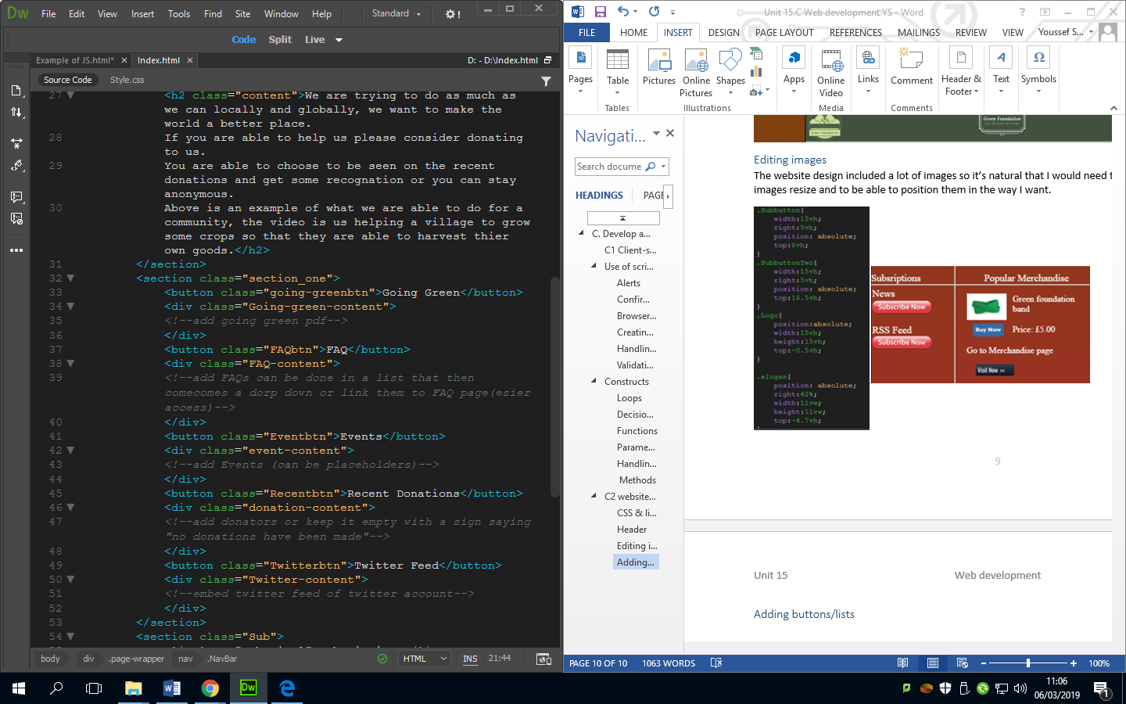

CSS

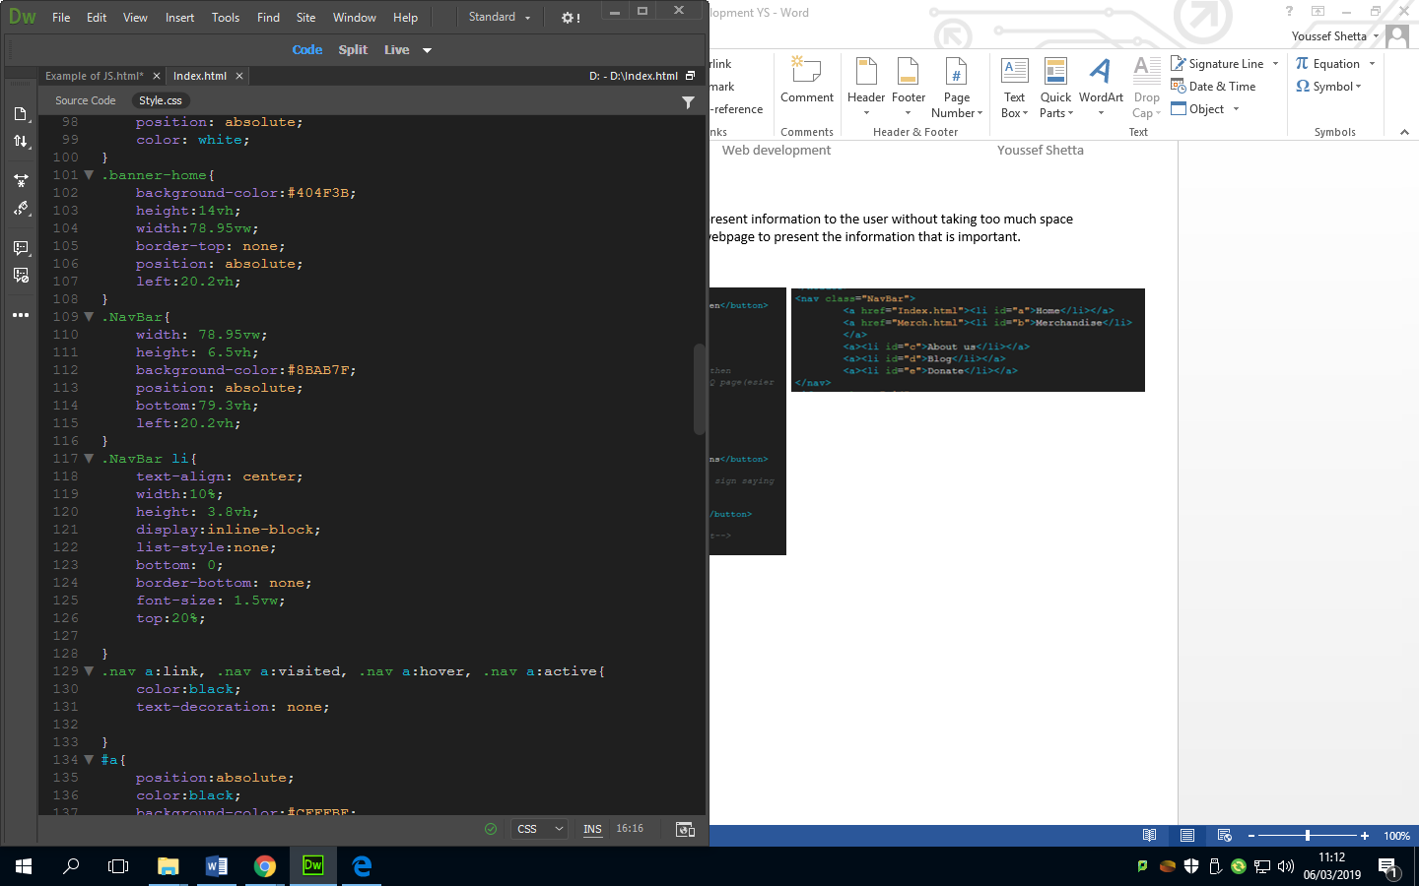

### Adding navigation bar

The navigation bar is just a list that is linked using the tag HREF and using the name of the webpage html file.

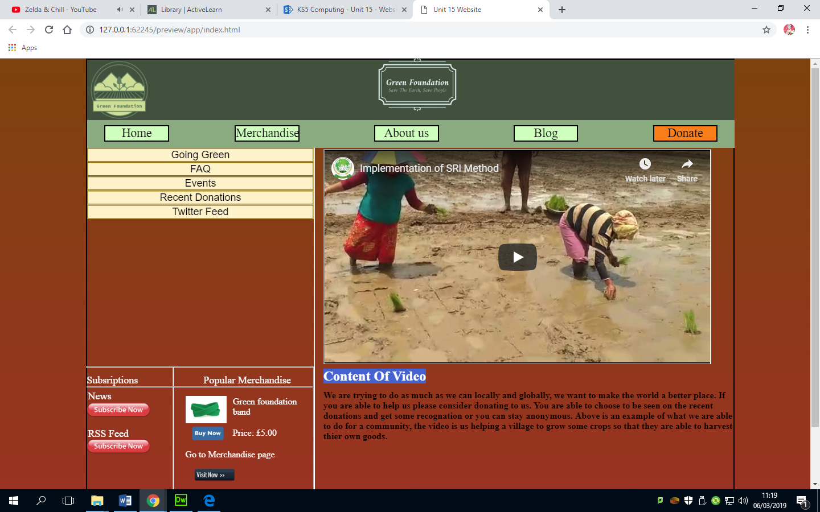

### Social media links

Below is the code and image of links to the social media. This is a part of the user’s requirements so it had to be implemented.

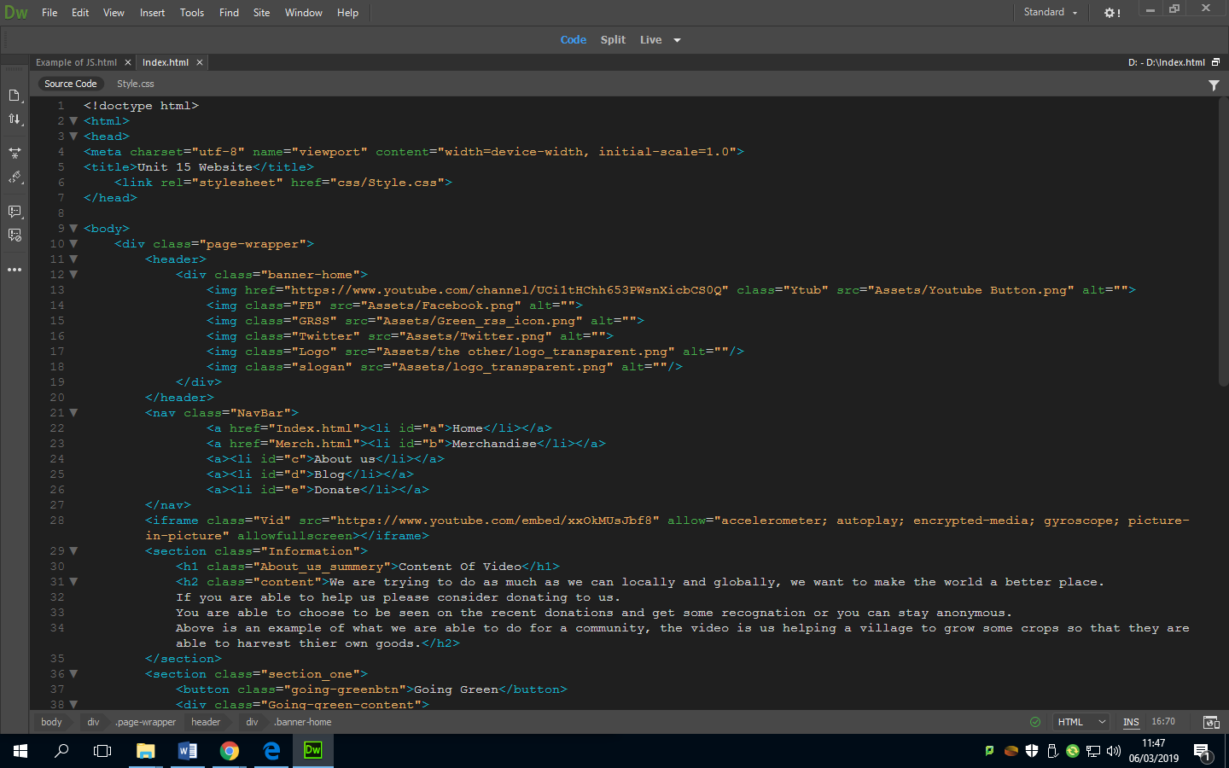

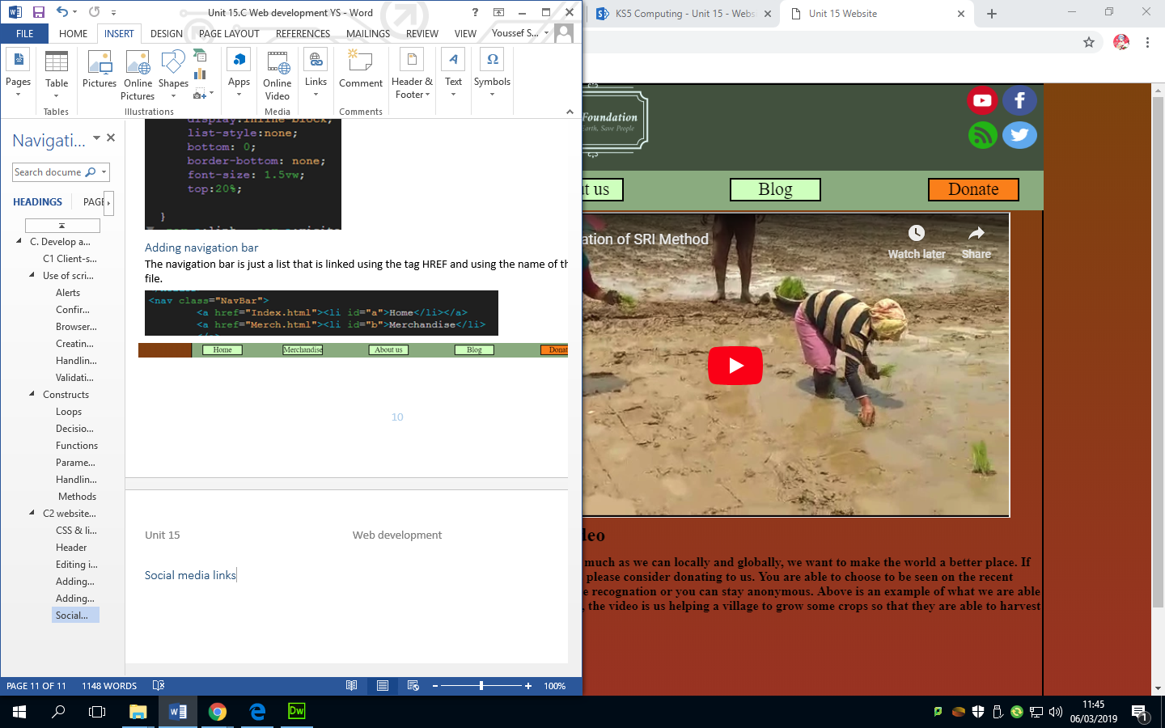

### Including downloadable resources (Going Green)

The client wanted me to use the resource of “going green” as a downloadable pdf that the visitor can use/look at. So what I did was put a link to a pdf of “going green” which sends the user to another tab that lets them download the pdf from the link.

The pdf was a resource that I found on <https://www.uncclearn.org/sites/default/files/inventory/going_green.pdf>

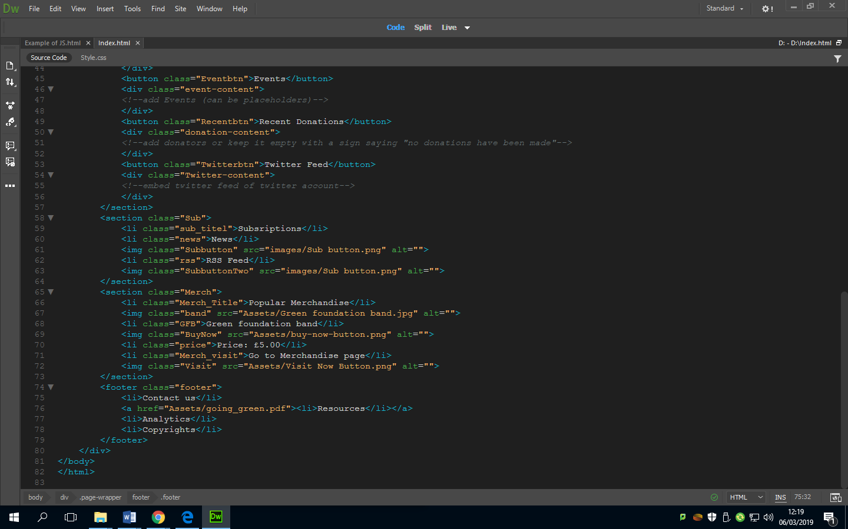

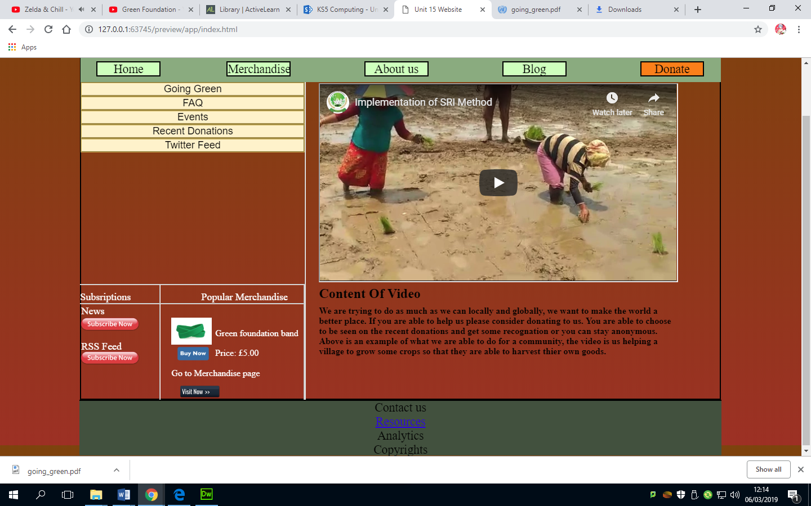

### Creating the charity profile

To create a charity profile I wanted to include a video and a description saying what the Green Foundation does. Below is the video and description I implemented. To get the video in the website I used YouTube’s embed button that gives the code to put it into the HTML document.

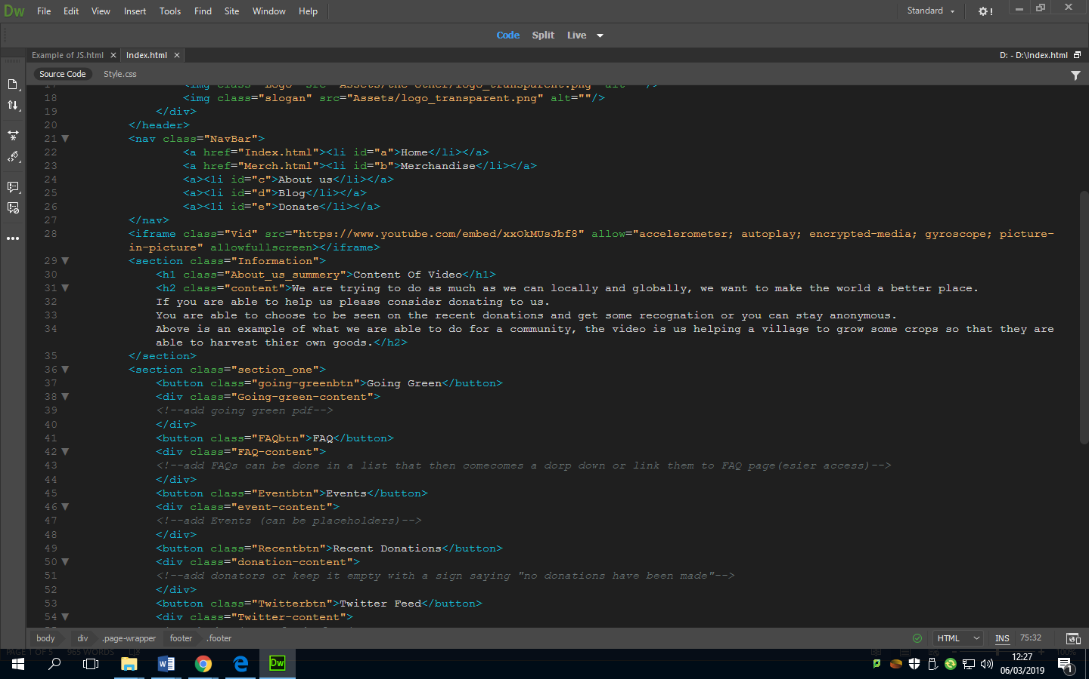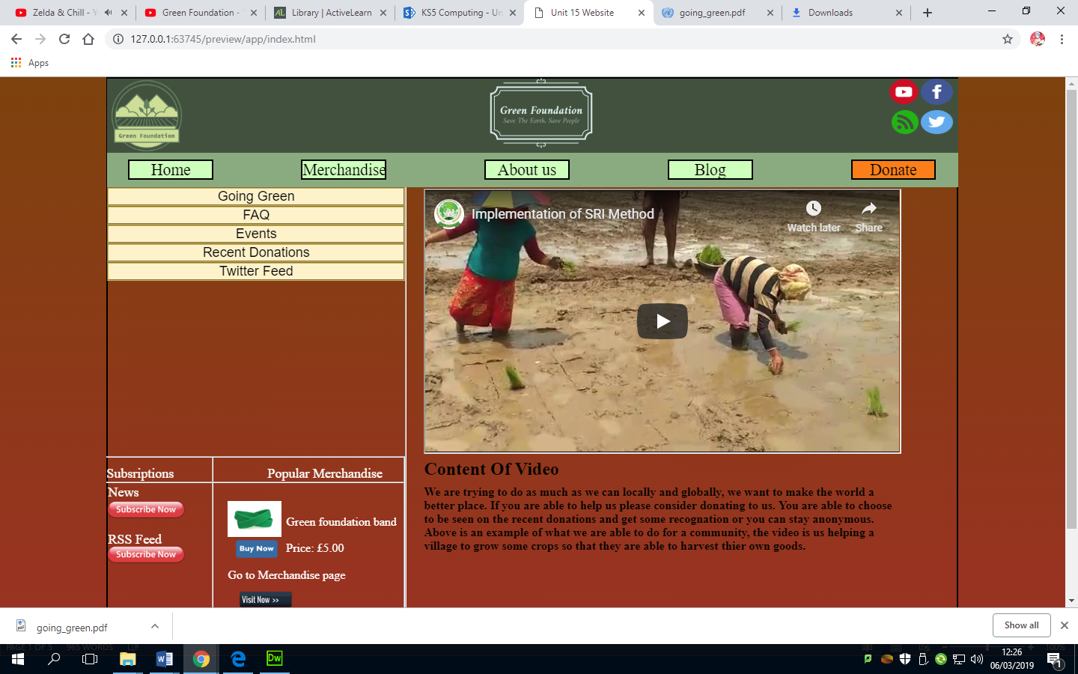

### Creating the donation section

The donation button is in the navigation bar so that people are able to see it when trying to navigate the website. This is then linked to PayPal which is a service that I want the organisation to use as it’s more secure than having their own system that can be exploited.

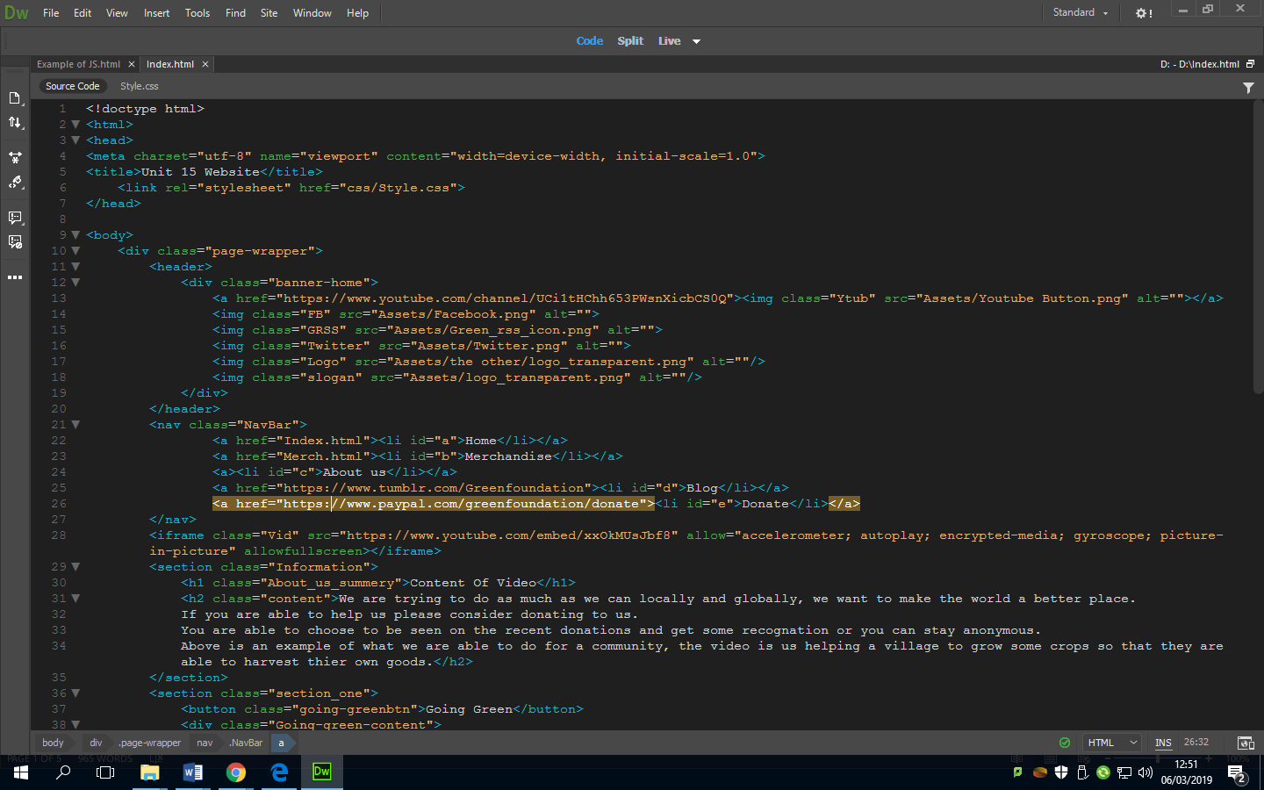

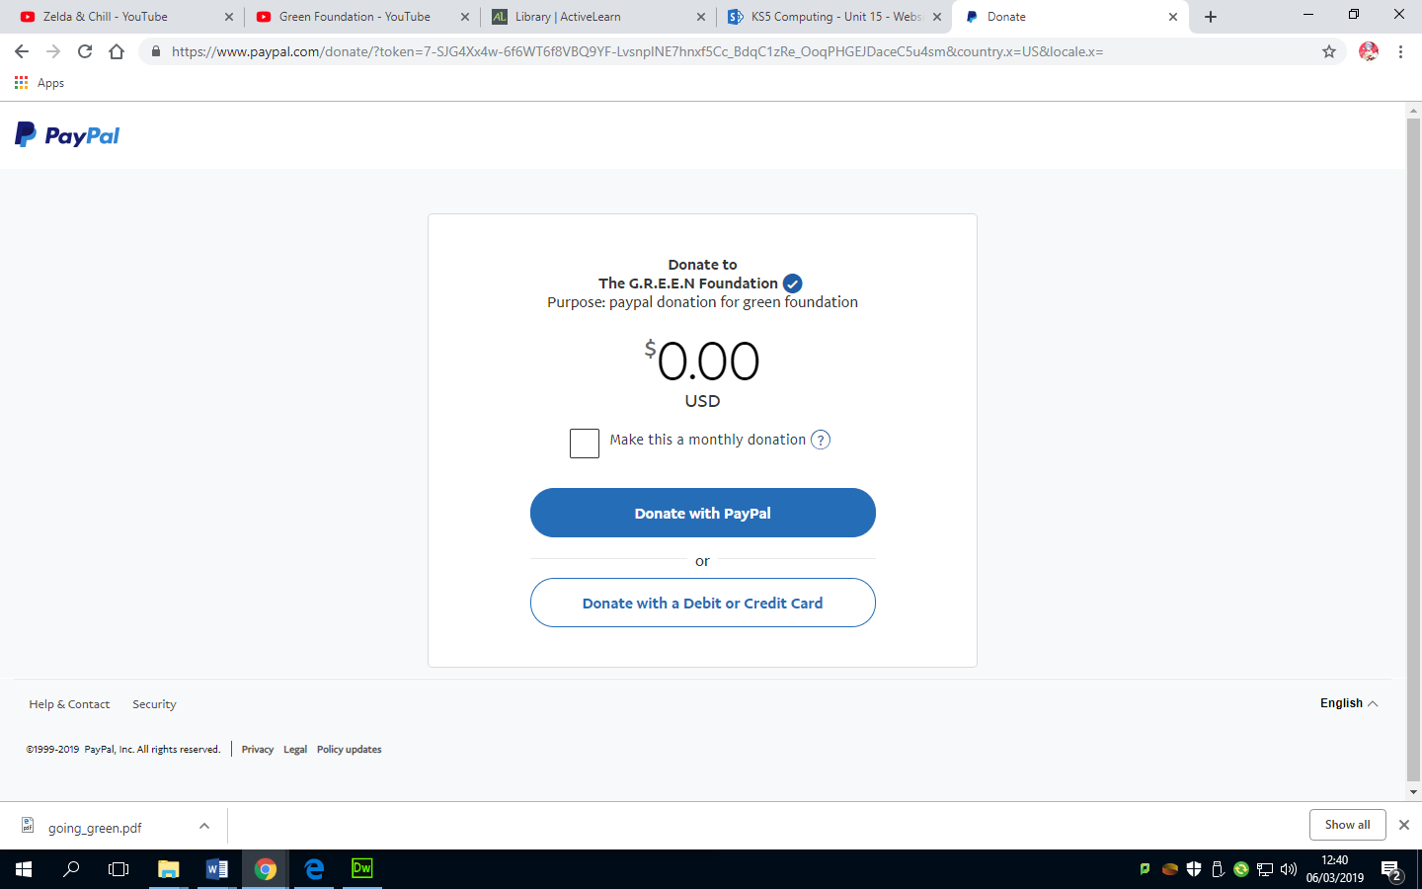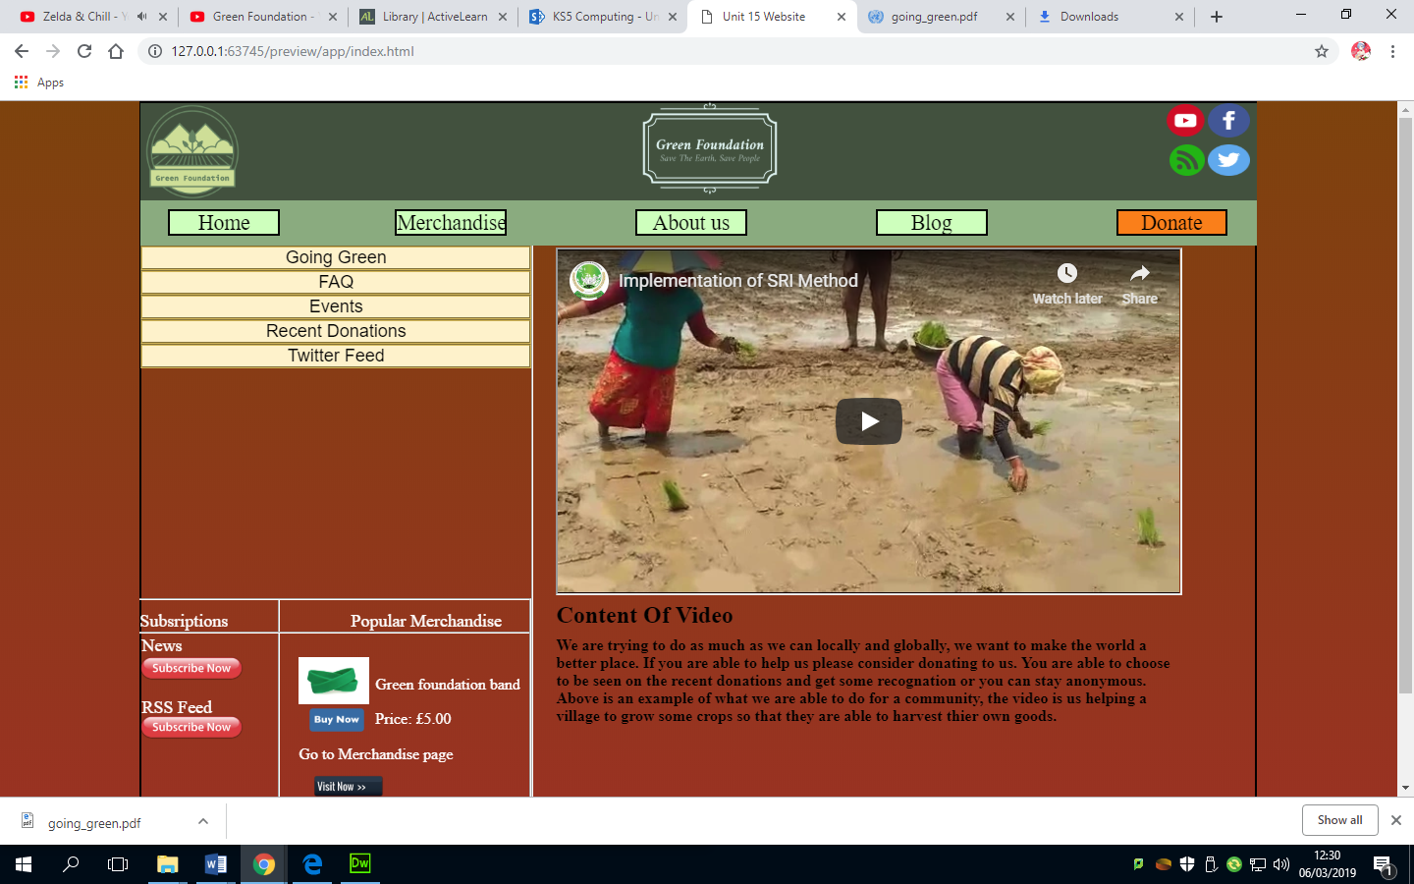

### Implementing the blog

For the client requirement of making a blog I want for an external blog that is related to the organisation, which I picked Tumblr for as it’s a blog making website that can host the blog for you. So I linked the blog in the navigation bar to Tumblr where people are able to comment like and repost the content that would be posted.



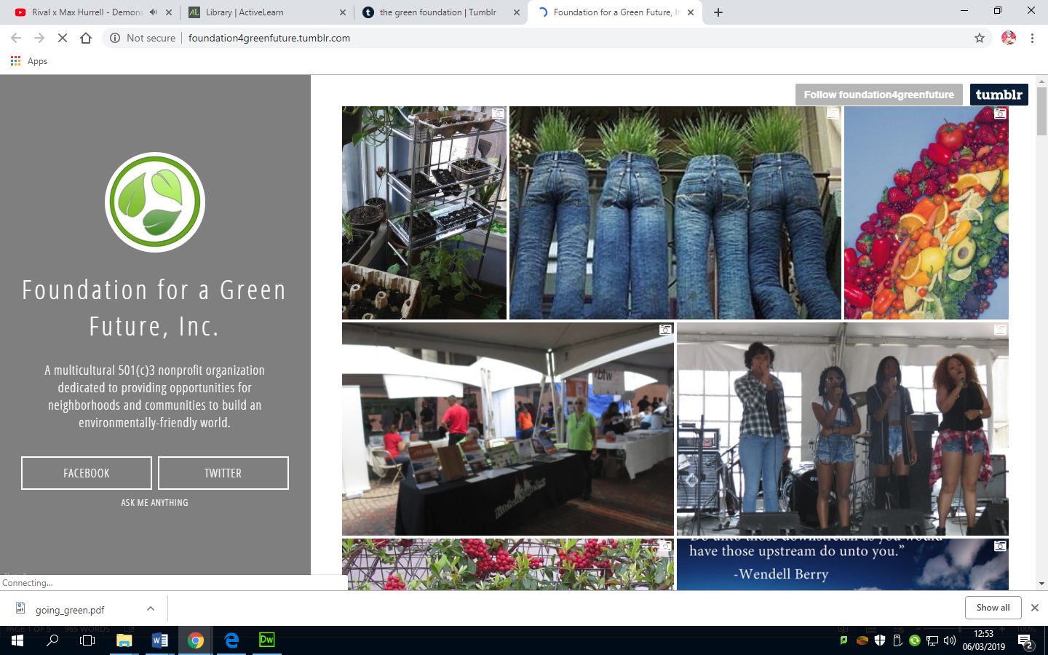

## P5 Testing the website for functionality, compatibility and usability.

## Testing

|  |  |  |  |  |  |
| --- | --- | --- | --- | --- | --- |
| Test number | Purpose of test | Page | Test data | Expected result | Actual results |
| 1 | Testing home button on the navigation bar. | Home.html | Click on the Home button on the navigation bar | Loads the home page | Loads the home page |
| 2 | Testing Merchandise button on the navigation bar. | Merch.html | Click on the merchandise button on the navigation bar | Loads the merchandise page | Loads the merchandise page |
| 3 | Testing the about us button on the navigation bar. | Aboutus.html | Click on the about us button on the navigation bar | Loads the about us page | Loads the about us page |
| 4 | Testing the blog button on the navigation bar. | blog.html | Click on the blog button on the navigation bar | Loads the blog page | Loads Tumblr |
| 5 | Testing the donate button on the navigation bar | Paypal.com | Click on the donate button on the navigation bar | Loads the PayPal donation service | Loads the PayPal donation service |
| 6 | Testing the drop down navigation bar | Any page | Click on the arrow on the navigation bar | Drops down or sends the navigation bar up out of sight | No drop down function |
| 7 | Testing the drop downs for going green | Home.html | Click on the arrow next to the going green on the left of the home page | Drops down a download button | No drop down just a download link under title. |
| 8 | Testing the download button for going green | Home.html | Click on the download button after drop down | Downloads the document | Sends the visitor to the pdf link. |
| 9 | Testing the FAQ Drop down | Home.html | Click on the drop down for FAQ | Panel drops down with frequently asked questions | Panel drops down with frequently asked questions |
| 10 | Testing the Events drop down | Home.html | Click on the drop down for Events | Shows current events and scheduled events | Shows current events and scheduled events |
| 11 | Testing the drop down for the recent donations | Home.html | Click on the recent donations drop down | Shows the recent person for donations | Shows the recent person for donations |
| 12 | Testing the twitter feed drop down | Home.html | Click on the drop down for the twitter feed | Shows an updated twitter post | Shows an updated twitter post |
| 13 | Testing the subscribe now button for the news letter | Home.html | Click on the subscribe now button | Sends emails to those who click it | Sends emails to those who click it |
| 14 | Testing the subscribe now for the RSS feed | Home.html | Click on the subscribe now button | Sends the visitor to the RSS feed | Sends the visitor to the RSS feed |
| 15 | Testing the buy now button for the popular merchandise | Home.html | Click on the buy now button | Sends the user to the check out | Sends the user to the check out |
| 16 | Testing the visit now button under the buy now button | Home.html | Click on the visit button | Sends the visitor to the merchandise page | Sends the visitor to the merchandise page |
| 17 | Testing if it works on internet explorer. | Home.html | Opening Home.html using internet explorer | Everything opens normally | Some lines from the box modelling extends more than it needs to. |
| 18 | Testing if it works on google chrome | Home.html | Opening Home.html using google chrome | Everything opens normally | It opens fine on google chrome. |
| 19 | Testing if it works on opera | Home.html | Opening Home.html using opera | Everything opens normally | It opens everything without errors. |
| 20 | Testing if it works on the browser Firefox | Home.html | Opening Home.html using Firefox | Everything opens normally | It opens with some paddings extending their position as the video position is also altered. |
| 21 | Testing if loading the home page works after changes on Firefox and internet explorer. | Home.html | Opening home.html using Firefox and internet explorer. | Everything opens normally | Opens home.html without any errors or misplaced boxes/paddings. |

### Review of my website

In this section, there are quotes from some of the potential users of the website.

“I don’t like the colours you used.”-Christian

“The green colour almost sends the message of money instead of nature, which is not what a charity is supposed to be about.”-Jordan

“I like how simple it is. Not too much to confuse the visitors”-Abeselom

“I like the logo it’s fitting.”-Talal

“I like how simple the navigation bar is.”-Sheldon

“Should have added more effects on the website, it’s boring.”-James

## M3 optimise a website to meet client requirements

To optimise the website to meet the client’s requirements I tried to make it accessible from phones and tables as well as pc which was the default. The only thing that had to be done was change the resolution of the website to meet the resolution the phones and tablets.

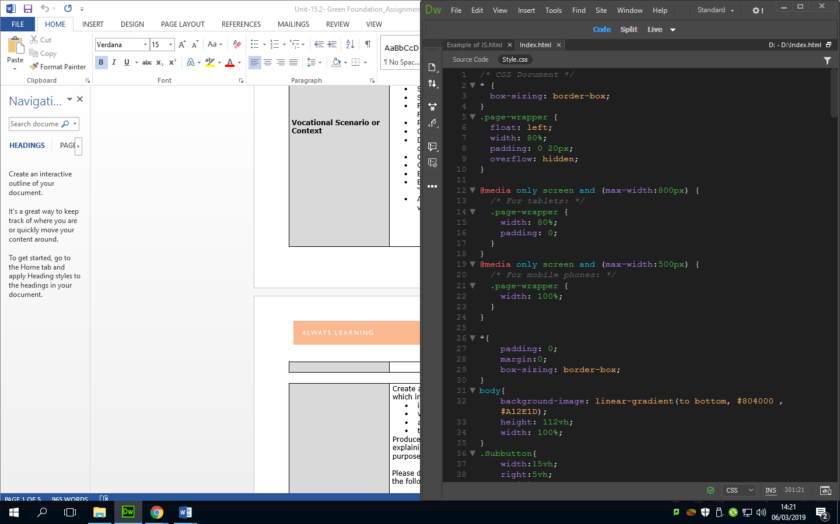

Above is the code I implemented which in theory would change the resolution of the webpage to fit the resolution of the phone/tablet. This would meet all the client’s requirements because it would help generate clicks and donations if it could be done through portable devices.

After testing the website I ran into a few errors that I had to change to make sure that it would meet the client’s requirements. In my testing section above test numbers 17, 18 and 20 had an error with the padding making it look very unappealing to the visitor. To fix this I had to change some values under the merchandise page and reposition the video in the middle of the page.

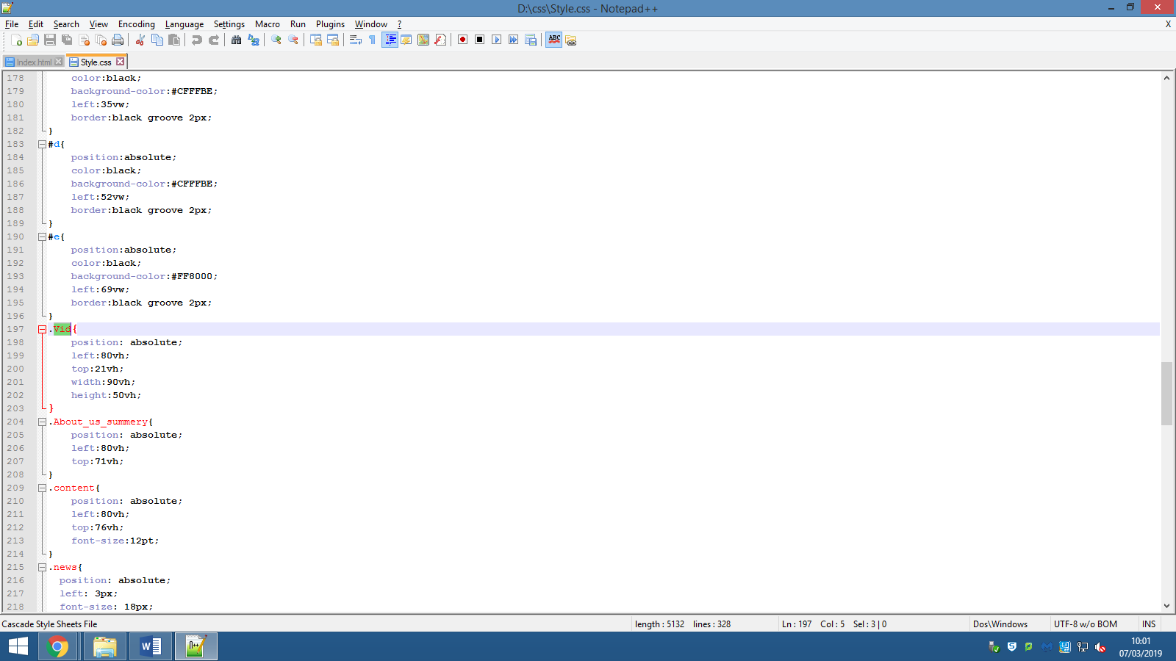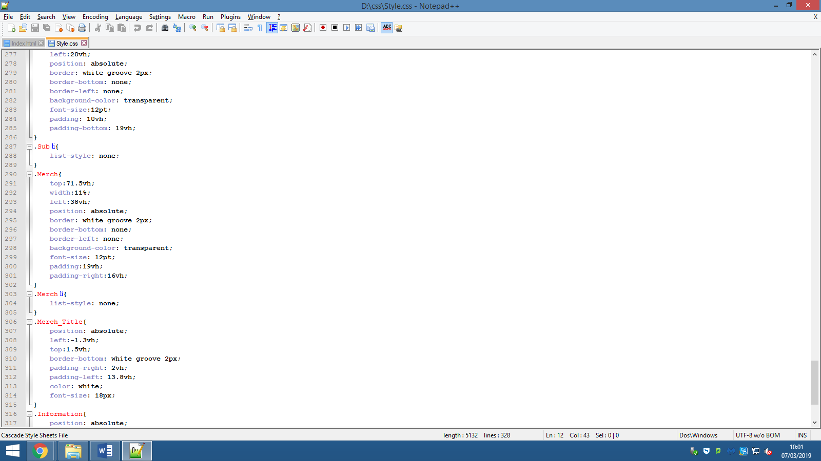

## D3 Demonstrate individual responsibility, creativity and effective self-management in the design, development and review of the website.

In this section of the report, I will discuss what I did to organise my time and manage myself to meet the end goal, which was to produce a plan and execute it to develop a website to meet a set of client requirements.

When starting this project, I firstly got all the requirements of the client and judged how much time I need to allocate to the creation cycle of the website. The proof of this can be displayed by the Gantt chart that was created.

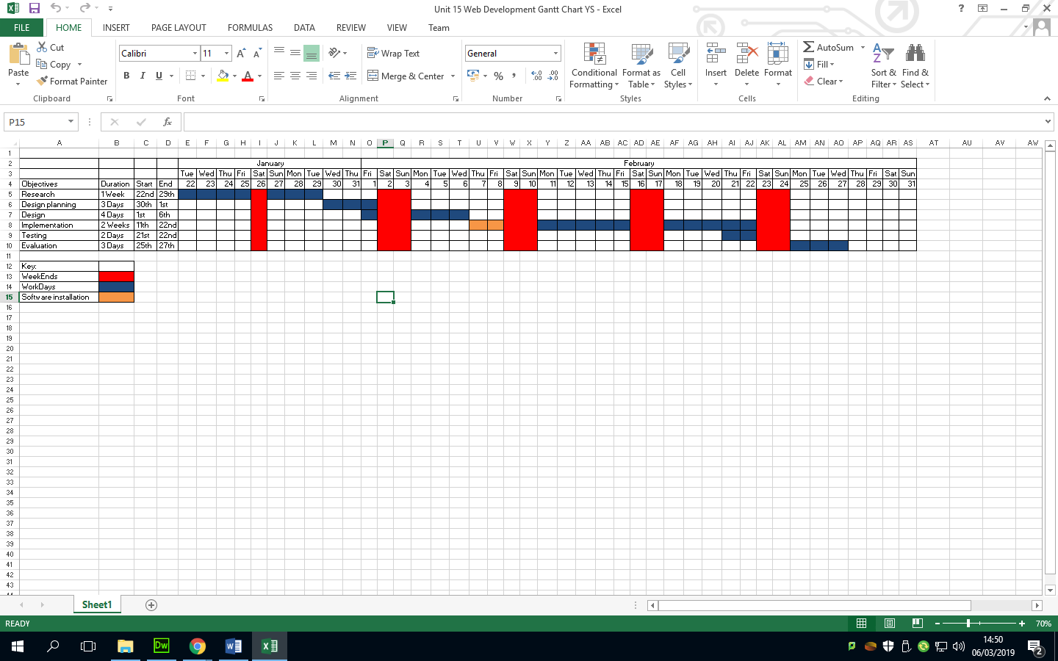

As you can see in the screenshot above, my estimation on getting the website up and going was for the 27th of February, but there was a problem with the software installation, as it took longer than 2-4 days which set the work back by a week. Despite the complications, I was able to use that time to work on the design further, to see what I could cut from it to make up for lost time. Now looking back at it I could have used other ways of coding the website that didn’t involve the software, such as using WIX.com to create a drag and drop website. However I wanted to use the web development project to develop my HTML, CSS and JavaScript knowledge, as well as having control over the code to not have messy code that could slow down the load time, which could have cost me the development of the website or the losing the client. Below is an accurate Gantt chart of how long the development cycle took.

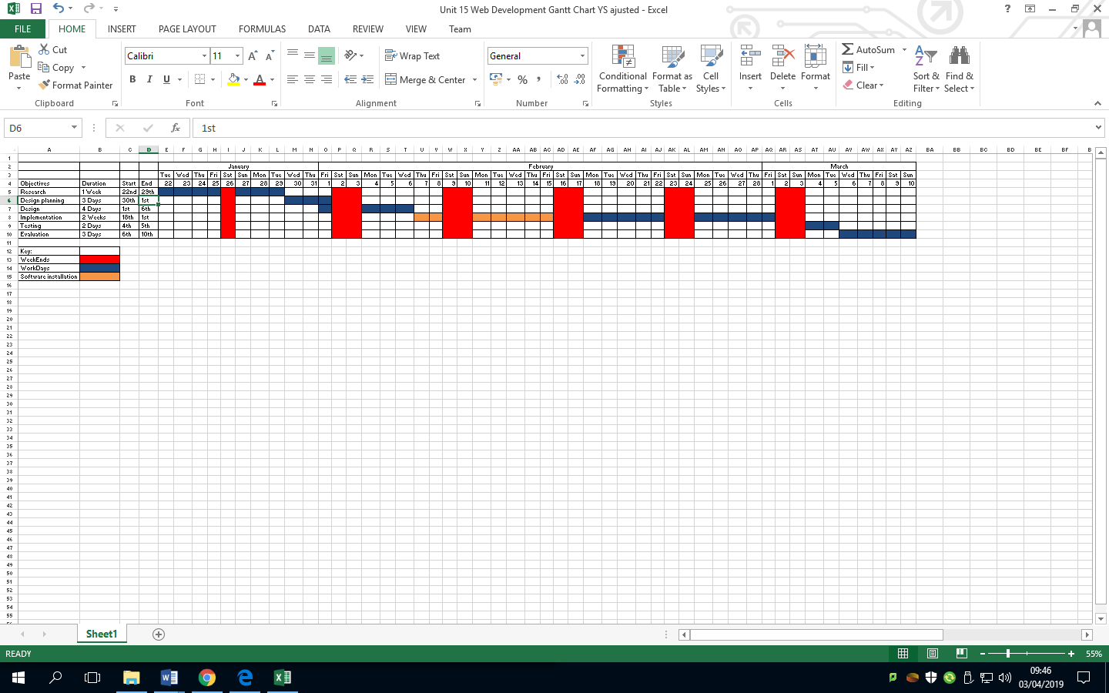

To gain inspiration for the website development cycle, I had to make a mind map and a mood board before drawing any of the designs out. This was done to make the production of the design smoother in the long run. With the design plan done, I was able to create multiple versions of the website designs on paper and then transferred them into a virtual copies. I thought it would be inefficient to do it on Microsoft Word as the shape tools are very hard to control, so I looked for a website or a software that lets me move shapes freely. Therefore, I decided to use Draw.io instead, which is a website that lets the user create designs, flowcharts and mind maps. Using this tool increased the efficiency of making the virtual copy of the website designs, with the process being much faster, so I was able to finish the designs, virtual and physical copies, in a week. Which then left me with a few weeks free to allocate to the implementation stage.

For the implementation stage I ran into a problem where the website development tool, Dreamweaver, was not installed. This incident made me wait nine days for the software to be installed. In retrospect, I could have done the coding in Notepad++ where I could then change the properties from a word file to a HTML file. This would have saved me time in the implementation phase, which would have shortened my Gantt chart to be similar to the first one.

I believe I managed my schedule effectively to finish this task - this can be shown on the 27th January where I completed work outside my usual schedule, because of how much time I had left. This work ethic stemmed from looking at the Gantt chart, and calculating how much time I have to finish everything. The website was of high importance, so I dedicated more time to the project and prioritized the gathering of information for the website design.

To summarise, I produced two Gantt charts to help myself manage my time, as well as model what my next few weeks would look like. Then I planned what the designs would look like by using mind maps and mood boards. For the design, I wanted a good software to save time so that I don’t have to use a software that isn’t traditionally used for designing projects. Implementation took less time than predicted, so it took less time then I initially planned for. The only time consuming process was the software installation at the work place.

# Bibliography

Pearson BTEC National computing student book was used in this report. Pages 520- 534.